Patient Information Leaflet

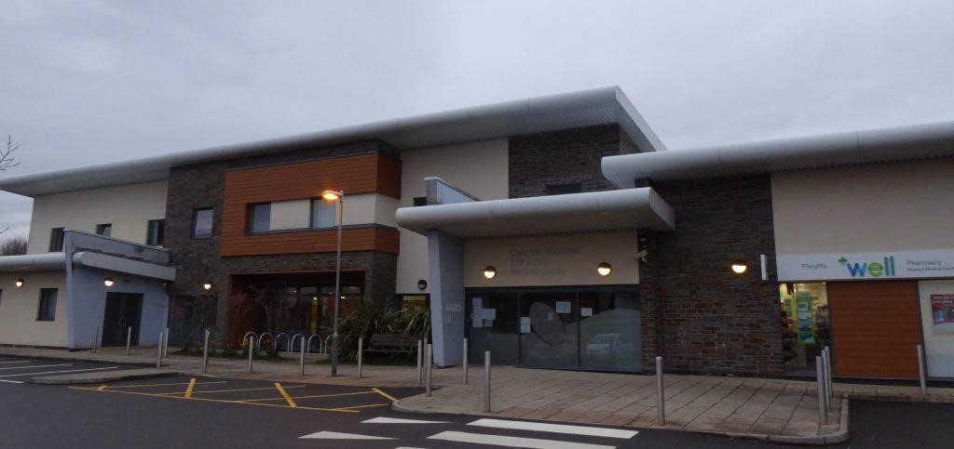

Hirwaun Medical Practice
Hirwaun Medical Centre
High Street
Hirwaun
Aberdare
CF44 9SL
Telephone: 01685 811999

https://hirwaunmedicalcentre.nhs.wales

About our Practice

Welcome to Hirwaun Medical Centre.
Our team are here to help and want to make your experience positive and offer you and your family excellent patient care.

Our Team

GPs | Dr Andreas W Erhardt (Senior Partner)  Dr Sara Wilson (Partner)  Dr Simon Evans (Salaried GP)  Dr Robert Williams (Salaried GP)  Dr Mary Hoptroff (Salaried GP)
Nurse Practitioner | Eirwen Turner
Practice Nurses | Barbara Pugh  Sian Williams  Leanne Morgan
Health Care Support Workers | Sara Hodgetts  Alison Lindley
Receptionists | Julie Evans  Kay Evans  Margaret Parfitt  Carolyn Rogers  Lizi Owens  Lucy Lake  Rachael Lloyd  Deborah Wilson
Business Manager | Joanna Watts-Jane
Practice Manger | Geraldine Hughes

The Practice is a non-limited GP Partnership

Practice Opening Hours

Phone lines are open from 8.00am until 6.30pm
Doors remain closed until 8.30am for telephone appointments and close at 6pm
Day | Open | Closed
Monday | 8:00 | 18:30
Tuesday | 8:00 | 18:30
Wednesday | 8:00 | 18:30
Thursday | 8:00 | 18:30
Friday | 8:00 | 18:30

Accessibility
Our modern purpose-built premises has disabled access and facilities for all patients and will always help where necessary.
Please let the receptionist know if you require additional assistance and we will make arrangements to book you in at a suitable time.
We have access to a translation service for our patients, and we can make adjustments for people’s sensory, communication, language and other needs, including online services.

Car Park
Please park with consideration in our car park. There are designated spaces for disabled patients.

Registering as a Patient
Please register in person at the reception desk. You will be required to complete two forms; a registration form and a health questionnaire. Please bring a form of ID with you to ensure you will be able to access online appointments and repeat prescriptions in future.
We cover the areas of Rhigos Village, Hirwaun, Pendryn, Penywaun, Trecynon and parts of Aberdare. Upon registration you will be offered a new patient check, we strongly advise you to attend as it helps us get to know you as a patient.

Change of Details
To help us to provide you with the best service please keep us up to date with any changes to your name, address and contact details. Your details are shared across the health board ( hospitals and vaccination teams) therefore it is really important that the contact information we hold for you is correct. If you move out of the practice catchment area you will be asked to register at the nearest doctor to your new address. We will inform the NHS Wales shared services partnership who will give you 30 days to register elsewhere.

Carer’s, Housebound and Military Veterans
If you look after somebody, or if you are looked after by a carer or if you are housebound, or a military veteran, please tell our reception staff. It is important that we have this information on your medical records so we can prioritise your health care.

Appointments

We offer appointments on the day for issues that are clinically urgent or appointments bookable in advance for less urgent or routine issues. If you are offered an appointment on the day, please ensure you can attend the surgery when requested.
Appointments can be booked over the telephone or online. If it is clinically urgent for the day, we advise you contact the surgery by telephone.
You have the right to request a doctor of your choosing; however it may not always be possible to accommodate your request, particularly if your appointment is urgent for on the day.
If you want advice, please speak to our reception staff, they are highly trained and will treat you with care and sensitivity. A brief explanation of the type of service you need from us will help them to direct you to the most appropriate person. To maintain a good level of access to our clinicians it is important that you let us know as soon as possible if you are unable to keep an appointment so that we can allocate it to another patient.
When phoning you will be asked the reason for your request. This will be so we can provide the best appointment for you.
Our Doctors appointments are usually 15 minutes long, our nursing team appointments are usually 10 minutes long. We do our best to keep to time during clinics but ask for your understanding when we don’t.

Your Local Pharmacy

Did you know that your community pharmacist can provide free confidential NHS advice and treatment without the need for an appointment with a GP. They cover many common ailments and are often able to provide treatment free of charge. Please contact your local pharmacy for more information. Details on the back page of this booklet.

Home Visits

To request a home visit please call the surgery before noon. Home visits are at the discretion of the doctors, please give the receptionist as much detail as possible when making the request and ensure you leave a contact telephone number. This practice has a strict policy that home visits are only available for those patients whose medical or physical condition makes attending to the surgery impossible

Chaperone

We respect your privacy, dignity and your cultural and religious beliefs. If you would like a chaperone during your consultation, please ask at reception.

Clinics

Surgery appointments are by prior arrangement only. We do not offer drop-in clinics.

The practice staff can provide the following services:
Urgent and non-urgent GP appointments, chronic disease management: diabetic clinics, respiratory clinics - Asthma/COPD, post-natal checks, baby clinic, contraception/HRT, phlebotomy, cervical screening, NHS travel vaccinations, annual influenza vaccine clinics, anticoagulation monitoring and wound care.

The practice may also work with external agencies who are experts in a given field to provide specific reviews for chronic disease management.

Patient Rights

As a patient you have the right to be registered with a General Practitioner and receive care from them. This may include medication or onward referral where appropriate and in line with local guidelines. You have the right of access to your medical records (as a subject access request) and the assurance that your records are confidential.

The practice does not discriminate on any grounds.

Patient Responsibilities

Patients also have a responsibility to the practice: -

1. Patients should attend their appointment on time. If this is not possible, they should contact the practice.
2. Patients are requested to contact the surgery prior to appointment if unable to attend.
3. Patients should understand that appointments are for the person who made the appointment only.
4. Many problems can be solved with advice alone; therefore, patients should not always expect a prescription.
5. Persistent failure to attend appointments will result in you being removed from the practice list.
4. We ask the patients to treat the staff and doctors with courtesy and respect.

Zero Tolerance

We operate a Zero Tolerance Policy to any form of verbal or physical aggression. Patients who are violent or threaten violence to any of our staff or other patients will be immediately referred to the Police.

Furthermore, the doctors will request the immediate removal of any patient who is aggressive or violent from our list. Patients who are verbally abusive to the Doctors or Practice Team will be given a written warning; any repeat of this behaviour will lead to their removal from our list of patients.

Removal from our list for violence or aggression may mean you are unable to register anywhere else locally.

Staff Qualifications

Our team is qualified to provide care and undertakes regular training to ensure that we provide the best and most up to date care. Please see below for their qualifications:
Dr Erhardt – State Exam Med 1992 – Freie Universität Berlin, MRCGP
Dr Wilson – MB BCh, MRCGP, BSc, DPD, DCH
Dr Evans – MB BCh, MRCGP, PGCert Med Ed
Dr Williams – MB BCh, BSc, MRCGP
Dr Hoptroff – MB BCh, MRCGP, Dip Counselling, Palliative Care Masters

Repeat Prescriptions

Please allow 72 working hours for a repeat prescription to be produced.

We accept repeat prescriptions either, in person by completing the right-hand side of your repeat prescription or by completing an acute medication request form which are available in reception, via email or via the NHS Wales app if you registered for this service. Unfortunately, we cannot accept requests over the telephone in the interests of patient safety.
Local pharmacies operate a delivery service for patients who are housebound.

All repeat prescriptions are reviewed regularly so that your condition can be monitored either by the doctor or by one of the specialist nurses or our pharmacist. We can often complete the review without the need for an appointment.

Administrative Requests

A continuation of a MED3/Sick certificate can be requested by speaking to our
receptionist.

Blood and Test Results

The Practice will usually inform you of any follow up needed from your blood test results either in writing, by text message or telephoning you. Some test results take longer to come back than others, if you have any concerns, please call the Practice and ask our receptionist for help. Please telephone after 10am for enquiries related to test results.

Training

The practice may occasionally host clinical students. These may be nurses, pharmacists or trainee doctors. They will be accompanied by one of our regular clinicians. You have the right to decline for them to be present for your consultation.

Non-NHS/Private Services

A fee will be charged for services not covered by the NHS. These include insurance reports, some vaccinations, private certificates, examinations for fitness to drive and other types of examination. NHS work is prioritised over private work and therefore there may be a wait for your request to be carried out.
Please speak to our reception team if you require a private service. The fee payable will be made clear to you prior to the work being carried out.

Data Protection, Confidentiality & GDPR

Our staff have access to your personal medical records. We ask you for medical information so you can receive the right care. This information is recorded by computer and/or your manual medical records. We are registered under the Data Protection Act. We will ensure that patient confidentiality is always maintained between all members of staff.
However, for the effective functioning of a multi-disciplinary team this sometimes requires that medical information about you is shared between members of this practice and on occasion other health care professional such as hospital consultants. If medical information about you is requested by other agencies such as insurance companies, solicitors we must have your written consent before any details are released.
ALL patient information is handled confidentially according to NHS guidelines. You have the right to access any personal information held under the Data Protection Act. We will not disclose any details to other agencies unless we have your written consent.
The GDPR requires practices to process data ‘fairly’ and in a ‘transparent manner’ which is ‘easily accessible and easy to understand’. This means that we must provide information to our patients about how the practice processes patient data. Please see our privacy notice on our website

Complaints

Most problems can be sorted out quickly and easily and often at the time they arise.

If you unable to resolve your complaint in this way and wish to make a formal complaint you should do so in writing as soon as possible after the event, giving as much detail as you can.

The practice follows the guidance set out by the NHS Wales Listening to People framework.

Please read the guidance on line or ask at reception for a copy.

If you are a registered patient, you can raise a concern about your own care. You are not able to raise a concern about someone else’s treatment without their written authority. If you raise a concern on behalf of someone else, we will communicate with them in the first instance (where possible) Please see the section about raising a concern on behalf of someone else.

Address your written concern to our Business Manager - Mrs Joanna Watts-Jane

Raising a concern on behalf of someone else

We keep to strict rules of medical and personal confidentiality. If you wish to raise a concern and are not the patient involved, we will require the written consent of the patient to confirm that they are unhappy with their treatment and that we can deal with someone else about it.

Where the patient is incapable of providing consent due to illness or accident, it may still be possible to deal with the concern. Please provide the precise details of the circumstances that prevent this in your covering letter.

Please note that we are unable to discuss any issues relating to someone else without their express permission, which must be in writing, unless the circumstances above apply.

If you are dissatisfied with the outcome of our investigation, you have the right to approach the public health service ombudsman for Wales. The contact details are:

The Public Health Services Ombudsman for Wales
1 Ffordd yr Hen Gae
Pencoed
CF35 5LJ
Telephone: 03007900203

Website: www.ombudsman-wales.org.uk

You can also request support from Llais who provide an independent advocacy service for those aged 18 and over. They can be contacted on 02920 235 558 or by email at enquiries@llaiscymru.org

Local Health Board

The practice is within the Cwm Taf Morgannwg University Health Board (CTMUHB) area. More information on CTMUHB is available on their website: https://ctmuhb.nhs.wales/

We are part of the North Cynon cluster, to find out more about clusters please visit the Primary Care One webpage: https://primarycareone.nhs.wales/cluster-working/cluster-area/find-a-cluster/cwm-taf-morgannwg-uhb/cynon-north

Out of Hours

The surgery is open Monday to Friday excluding bank holidays. If you have a medical problem that cannot wait until the Practice opens, you have various options:

- Your local pharmacy maybe able to help with common ailments
- Call NHS Direct 111 on 111
- Visit the NHS 111 Wales website - https://111.wales.nhs.uk/
- Cwm Taf GP Out of hours 0300 123 50 60

If you are experiencing chest pain, difficulties in breathing, have signs of a stroke or profuse bleeding please ring 999

These services are commissioned by the Local Health Board



